Jack de los Santos
1234 S Vernon Ave
Mercedes, TX 78570
(Cell) 956-555-9876
jdlsantos@gmail.com
Career Objective: Seeking a career, with opportunity to grow with the company.
Education: Texas State Technical College, Harlingen, Texas
Associates in Applied Science/ Automotive Technology
May 2015/ GPA 3.88
Texas State Technical College, Harlingen, Texas
Associates in Applied Science/ Air Condition & Refrigeration Technology
August 2013/ GPA 3.82
Mercedes High School/ High School Diploma/ Mercedes, Texas/ May 2007
Employment: Fairfield Inn & Suites October 2013 - August 2014
1005 Fairfield Blvd, Weslaco, TX 78596
Maintenance Worker
Performing preventative maintenance on room and hotel to keep up with Marriott Standards. Keeping communication with staff and guest while displaying great customer service.
United States Marine Corps October 2007 – October 2011
Twentynine Palms, CA 92278
Heavy Equipment Operator/ Corporal
Loading and unloading truck with supplies to support troops in different locations. Being a mentor to my subordinates that have little or no experience in the process. Keep workflow at a steady pace to remain on schedule. Perform preventative maintenance on our equipment.
Summary of Qualifications: Certification of Security Clearance, Work well with others, Ability to complete tasks in a timely manner
Specialized Skills: Commercial Driver License/ Endorsements: Tanker, Double/Triple, and Passenger
Voluntary Community Work: Active member of Knights of Columbus, Mercedes, Texas
References Available Upon Request

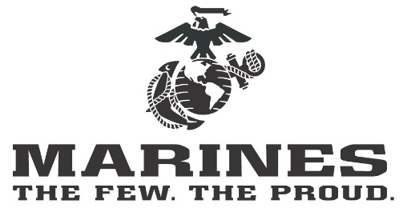
Jack de los Santos

1234 S Jackson Ave
Harlingen, TX 78570
(Cell) 956-555-9876
jdlsantos@gmail.com

Career Objective Seeking a public sector career that takes advantage of extensive military logistics training and experience in the United States Marine Corps.

Summary of Commercial Driver License/Endorsements: Tanker, Double, Triple, and Qualifications Passenger.

Security Clearance Certification. Work well with others. Ability to complete tasks in a timely manner.

Experience United States Marine Corps
Twenty-nine Palms, CA 92278
Heavy Equipment Operator/Corporal
2007–2011

Coordinated trucking operations involving transport of troops, supplies, and equipment to different locations. Executed complicated workflow at a steady pace to maintain schedule Mentored subordinates who had little or no experience. Performed preventative maintenance on equipment.
Fairfield Inn & Suites
1005 Fairfield Blvd, Weslaco, TX 78596
Maintenance Worker
2013–2014

Performed preventative maintenance on rooms of hotel to comply with Marriott Standards. Maintained communication with staff and guests while displaying great customer service.

Education Texas State Technical College, Harlingen, TX Associates in Applied Science/Automotive Technology
GPA 3.88/May 2015

Texas State Technical College, Harlingen, TX
Associates in Applied Science/Air Condition & Refrigeration Technology
GPA 3.82/August 2013

Mercedes High School/Graduated/Mercedes, TX/May 2007

Affiliations Active member of Knights of Columbus, Mercedes, Texas.

References Available Upon Request

